ReCoverCA Homebuyer Assistance Program
Homebuyer Event – Social Media Post (template language)
Feb 28 – Event in Marysville (Yuba County)

(Graphic)
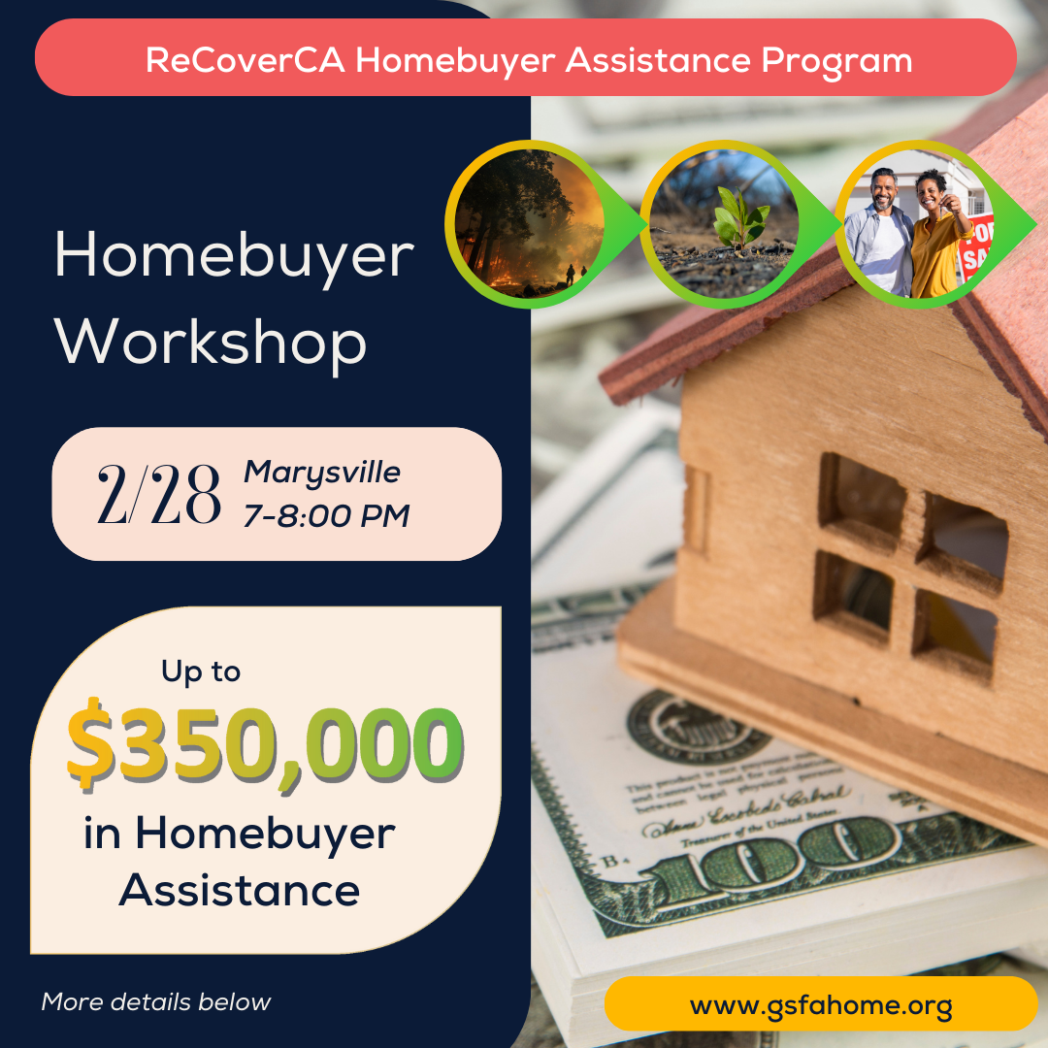

(Post body)
🏠 Yuba County Residents -- If you were living in Zip Code 95901 in Yuba County in 2017, within a High or Very High Fire Severity Zone, you could receive up to $350,000 to help you buy a home in California outside these high-risk areas.
Join us on February 28, 2025 for a FREE workshop for the ReCoverCA Homebuyer Assistance Program.
Event Details: 🗓 Date: February 28, 2025
🕖 Time: 7:00-8:00 PM
📍 Location: Tri-Counties Community Center, 1830 B. St., Marysville, CA 95901
This workshop is open to households impacted by the 2017 wildfires in Yuba County, as well as professionals supporting recovery efforts or providing community outreach.
🔑 What you’ll learn:
- How to apply for homebuyer assistance up to $350,000.
- Eligibility requirements, income limits, and the application process.
- Step-by-step guidance from experts in the field.
Space is limited – RSVP today!
https://qrco.de/bfim4d
#ReCoverCA #yubacounty #cascadefire #HomebuyerAssistance #DownPaymentAssistance #WildfireRecovery #CommunityRecovery #gsfa

